**Practical Exercise: Classic Observability**

Training Objective

Learn how to set up and view dashboards to analyze statistics of WSO2 Micro Integrator.

High-level Steps

* Install and set up monitoring tools.
* View the dashboards to see and analyze service mediation statistics.

Prerequisites

Set up classic observability by downloading **WSO2 EI Analytics**. Follow the instructions given below.

Set up MI Analytics

**Note**

* This solution is recommended only for users who are using WSO2 EI 7.0.0 and want to migrate in to a newer version while retaining the already existing analytics data.
* From WSO2 EI 7.1.0 onwards, users are recommended to use WSO2's improved cloud-native observability solution.

How it works

[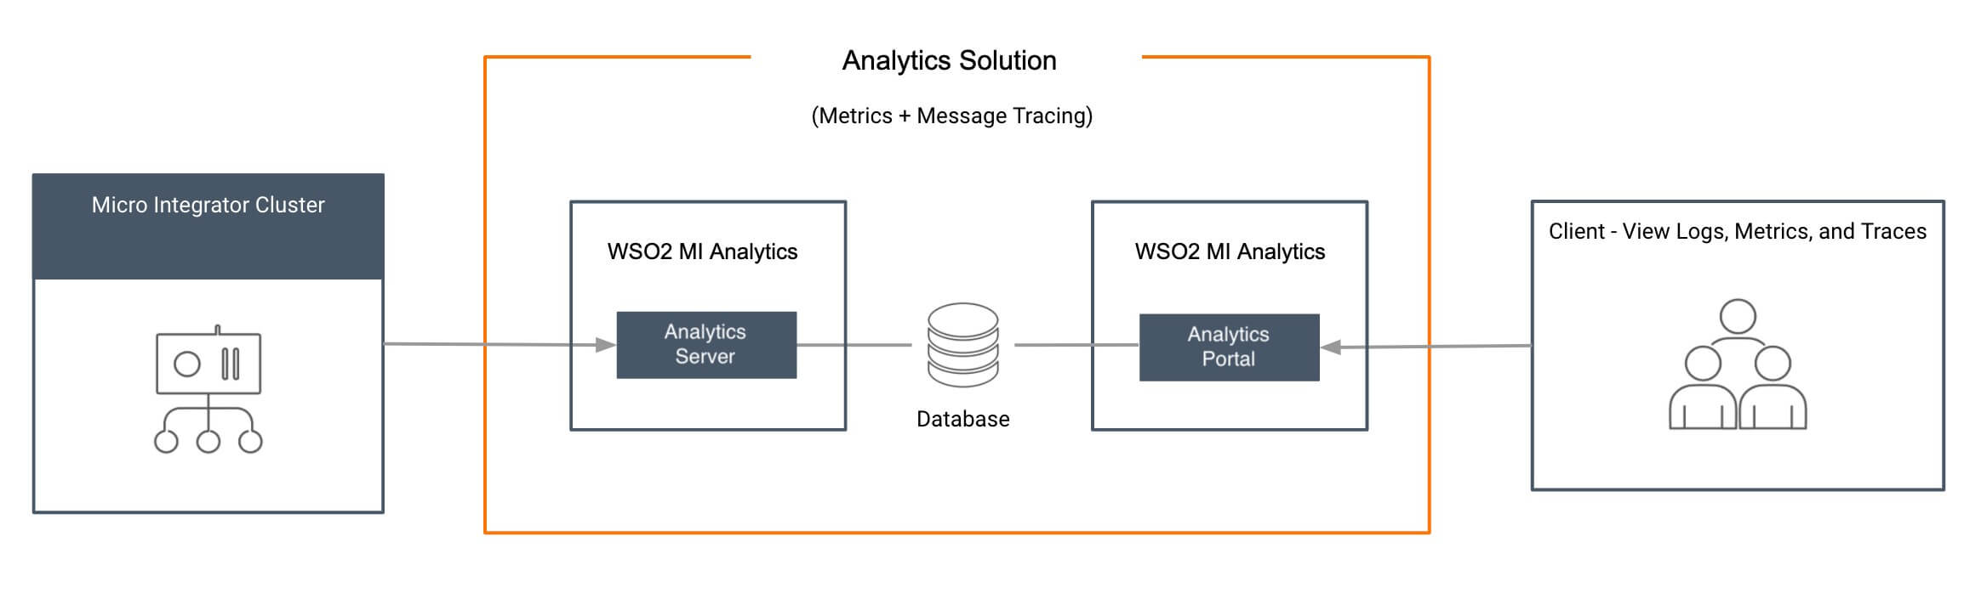](https://apim.docs.wso2.com/en/4.1.0/assets/img/integrate/mi-analytics/analytics-architecture.jpg)

MI Analytics consists of two components: **Server** and **Portal**. The server processes the data streams that are sent from the Micro Integrator and publishes the statistics to a database. The portal reads the statistics published by the worker and displays the statistics. The server and portal are connected through the database.

Follow the instructions given below to enable Analytics in the Micro Integrator profile.

System requirements

You will be running three servers (Analytics server, MI Analytics portal, and the Micro Integrator) for this solution. Be sure that you have the required system specifications to run each server.

Step 1 - Download the servers

**Download Integrator Analytics**.

* 1. Go to the WSO2 Enterprise Integrator [product page](https://wso2.com/integration/), click **TRY IT NOW**, and then go to the **Other Resources** section.
  2. Click **Integration Analytics** to download the distribution.

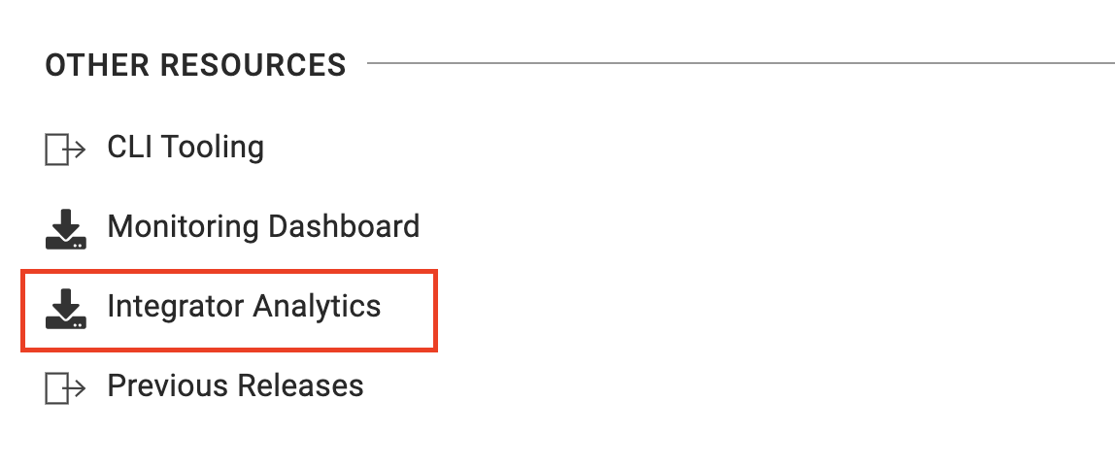

**Info**

* The location of your Analytics installation will be referred to as <MI_ANALYTICS_HOME>.

**Download and**[**install the Micro Integrator**](https://apim.docs.wso2.com/en/4.1.0/install-and-setup/install/installing-the-product/installing-mi).

Step 2 - Configure the Micro Integrator

Step 2.1 - Enable statistics monitoring

To enable statistics monitoring for the Micro Integrator, add the following parameters in the deployment.toml file of your Micro Integrator. This file is stored in the <MI_HOME>/conf.

[mediation]

flow.statistics.enable=true

stat.tracer.collect_payloads=true

stat.tracer.collect_mediation_properties=true

Step 2.2 - Enable data publishing to MI Analytics

Follow the instructions below to configure the Micro Integrator to publish data to MI Analytics. Analytics publishing can be configured in the [monitoring] section of the <MI_HOME>/conf/deployment.toml file as shown below.

**Note**

By default, the Micro Integrator is internally configured (with the following) to connect with an Integrator Analytics server running on the same Virtual Machine (VM). To change the default setup, you need to add the following to the deployment.toml file and update the values.

[monitoring]

ei_analytics.server_url = "tcp://localhost:7612"

ei_analytics.auth_server_url = "ssl://localhost:7712"

ei_analytics.username = "admin"

ei_analytics.password = "admin"

If the Analytics nodes run in cluster mode or in different VMs, you can configure the ei_analytics.server_url and the ei-analytics.auth_server_url parameters in a load balancing manner. For more information, see, [Set up load balancing](https://apim.docs.wso2.com/en/latest/mi-analytics/setting-up-mi-analytics/#step-25-optionally-set-up-load-balancing).

Step 2.3 - Optionally, enable statistics for ALL artifacts

If you want to collect statistics for **all** your integration artifacts, be sure to add the following parameter under the [mediation] header in the deployment.toml file in addition the [parameters explained above](https://apim.docs.wso2.com/en/latest/mi-analytics/setting-up-mi-analytics/#step-2-configure-the-micro-integrator):

flow.statistics.capture_all=true

Alternatively, you can enable statistics for selected artifacts as explained below.

Step 2.4 - Optionally, enable statistics for specific artifacts

Let's use the integration artifacts from the [service chaining](https://apim.docs.wso2.com/en/4.1.0/tutorials/integration-tutorials/exposing-several-services-as-a-single-service) tutorial.

**Warning**

It is **not recommended to enable tracing in production environments** as it generates a large number of events that reduces the performance of the analytics profile. Therefore, tracing should only be enabled in development environments.

**If you do not have the integration artifacts from the service chaining tutorial**

If you did not try the [service chaining](https://apim.docs.wso2.com/en/4.1.0/tutorials/integration-tutorials/exposing-several-services-as-a-single-service) tutorial yet:

1. Download the [pre-packaged project](https://github.com/wso2-docs/WSO2_EI/blob/master/Integration-Tutorial-Artifacts/Integration-Tutorial-Artifacts-EI7.1.0/service-orchestration-tutorial.zip) for the **service chaining** use case.
2. [Open WSO2 Integration Studio](https://apim.docs.wso2.com/en/4.1.0/integrate/develop/installing-wso2-integration-studio) and [import the pre-packaged project](https://apim.docs.wso2.com/integrate/develop/importing-projects).

**REST API artifact**

Follow the steps below to enable statistics and tracing for the **REST API** artifact:

1. Select HealthcareAPI in the canvas of WSO2 Integration Studio to open the **Properties** tab.
2. Select **Statistics Enabled** and (if required) **Trace Enabled** as shown below.

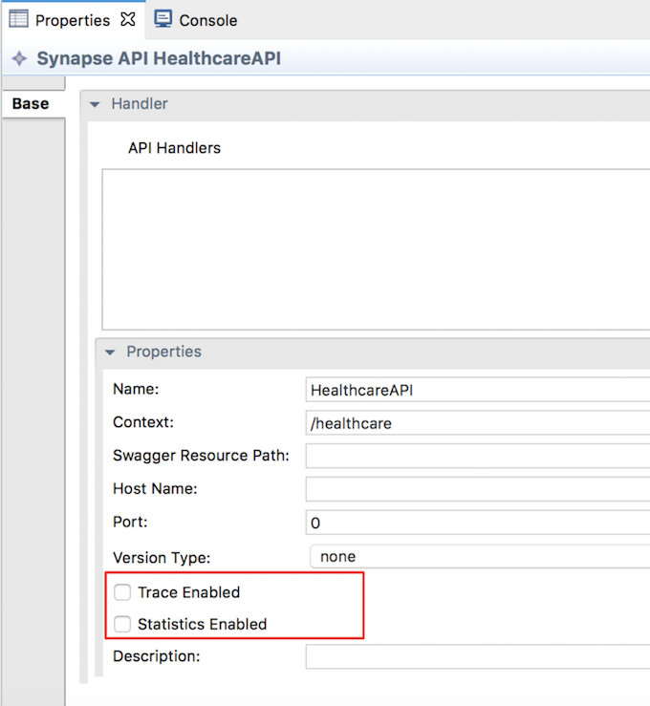

**Endpoint artifacts**

Follow the steps below to enable statistics for the **endpoint** artifacts:

1. Select the required endpoint artifacts from the project explorer.
2. Select **Statistics Enabled** and (if required) **Trace Enabled** as shown below. [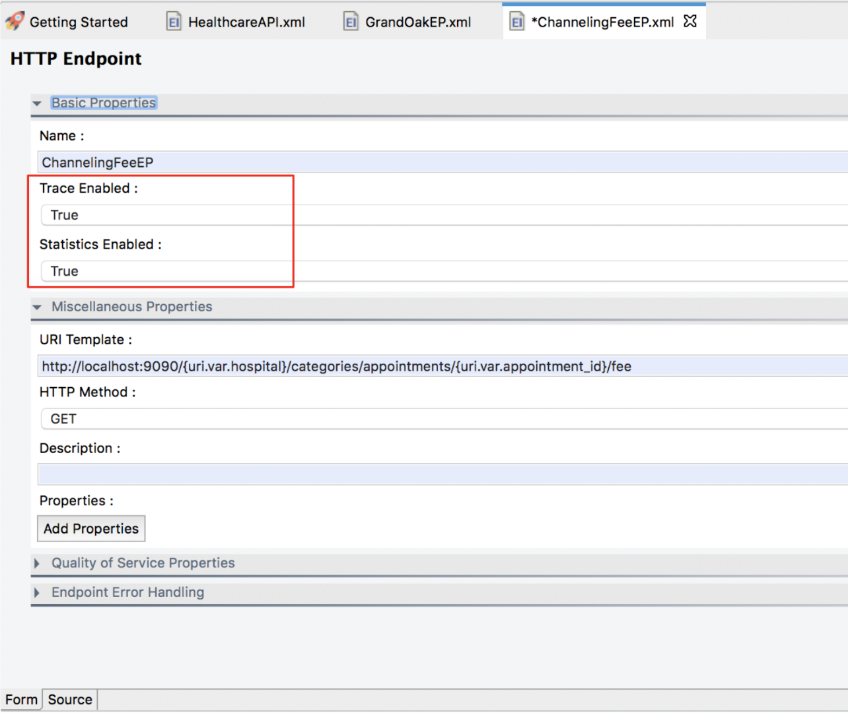](https://apim.docs.wso2.com/en/4.1.0/assets/img/integrate/mi-analytics/endpoint-properties.png)

Step 2.5 - Optionally, set up load balancing

You can send events to multiple Analytics servers either by sending the same event to many Analytics servers or by load balancing events among a set of servers. This handles the failover problem. When events are load balanced within a set of servers and if one receiver cannot be reached, events are automatically sent to the other available and active Analytics servers.

**Load balancing across a group of servers**

To configure this setup, configure the Analytics receiver URL specified in the Micro Integrator as a comma-separated list of Analytics servers.

The format of the receiver URL should be as follows:

tcp://<**Analytics-1**>:<**port**>,tcp://<**Analytics-2**>:<**port**>,tcp://<**Analytics-3**>:<**port**>

Example configuration in the deployment.toml file of the Micro Integrator:

[monitoring]

ei_analytics.server_url = "tcp://10.100.2.32:7611, tcp://10.100.2.33:7611, tcp://10.100.2.34:7611"

ei_analytics.auth_server_url = "tcp://10.100.2.32:7612, tcp://10.100.2.33:7612, tcp://10.100.2.34:7612"

ei_analytics.username = "admin"

ei_analytics.password = "admin"

[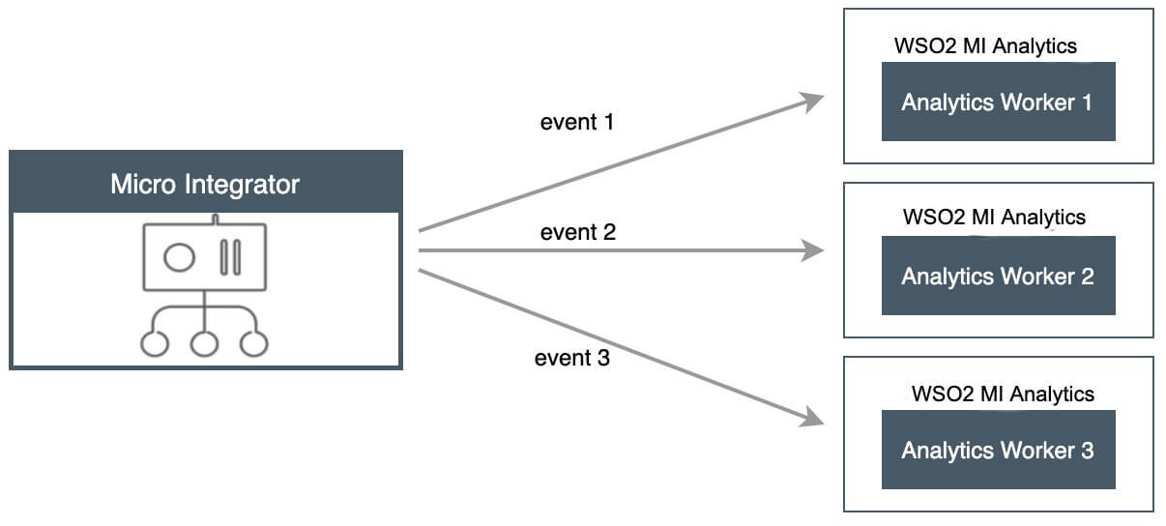](https://apim.docs.wso2.com/en/4.1.0/assets/img/integrate/mi-analytics/ob-lb-events-to-servers.jpg)

This handles failover as follows:

* If Analytics Receiver-1 is marked as down, then the Micro Integrator will send the data only to Analytics Receiver-2 and Analytics Receiver-3 in a round robin manner.
* When the Analytics Receiver-1 becomes active after some time, the Micro Integrator automatically detects it, adds it to the operation, and again starts to load balance between all three receivers. This functionality significantly reduces the loss of data and provides more concurrency.

**Load balancing across multiple groups of servers**

In this setup, there are two sets of servers that are referred to as set-A and set-B. You can send events to both the sets. You can also carry out load balancing for both sets as mentioned in [Load balancing across a group of servers](https://apim.docs.wso2.com/en/latest/mi-analytics/setting-up-mi-analytics/#load-balancing-across-a-group-of-servers). This scenario is a combination of load balancing between a set of servers and sending an event to several receivers.

* An event is sent to both set-A and set-B.
* Within set-A, it is sent either to Analytics A1 or Analytics A2.
* Similarly within set-B, it is sent either to Analytics B1 or Analytics B2.
* In the setup, you can have any number of sets and any number of servers as required.

[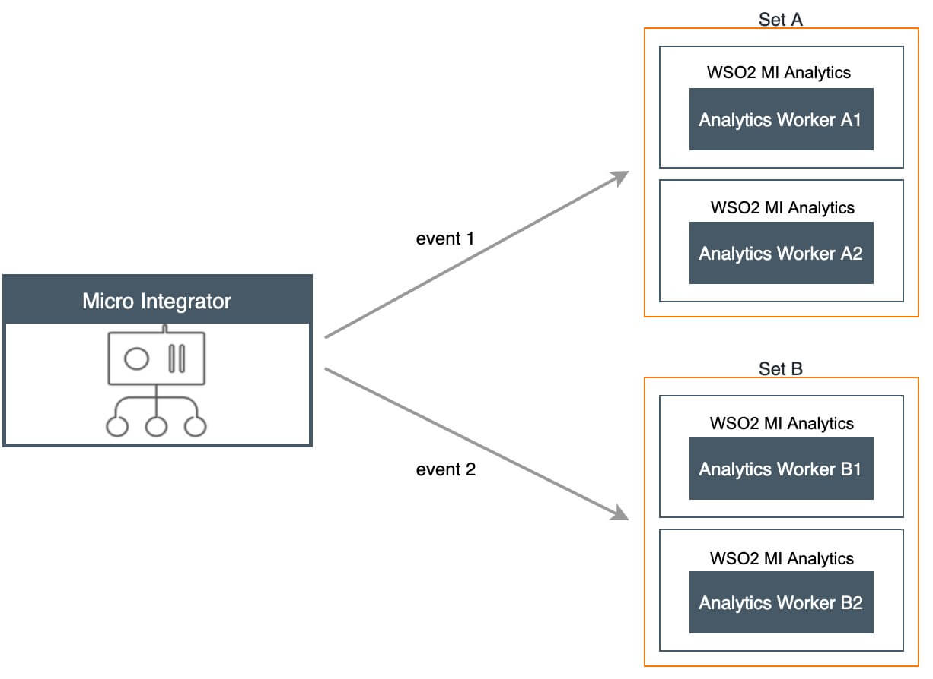](https://apim.docs.wso2.com/en/4.1.0/assets/img/integrate/mi-analytics/ob-lb-to-sets-of-servers.jpg)

Similar to the other scenarios, you need to describe the server URLs as the receiver URL in the Micro Integrator configuration. The sets should be specified within curly braces separated by commas. Furthermore, each receiver that belongs to the set should be within the curly braces and with the receiver URLs in a comma-separated format.

The format of the receiver URL should be as follows:

{**tcp**://Analytics-A1:port, tcp://Analytics-A2:port},{**tcp**://Analytics-B1:port, tcp://Analytics-B2:port}

Example configuration in the deployment.toml file of the Micro Integrator:

[monitoring]

ei_analytics.server_url = "{tcp://10.100.2.32:7611, tcp://10.100.2.33:7611}, {tcp://10.100.2.34:7611, tcp://10.100.2.35:7611}"

ei_analytics.auth_server_url = "{tcp://10.100.2.32:7612, tcp://10.100.2.33:7612}, {tcp://10.100.2.34:7612, tcp://10.100.2.35:7612}"

ei_analytics.username = "admin"

ei_analytics.password = "admin"

**Sending all events to several analytics servers**

This setup involves sending all the events to more than one Analytics server. This approach is useful when you want to have multiple Analytics servers to analyze the same events simultaneously. For example, as shown below, you can configure the Micro Integrator to publish the same event to both Analytics servers at the same time.

[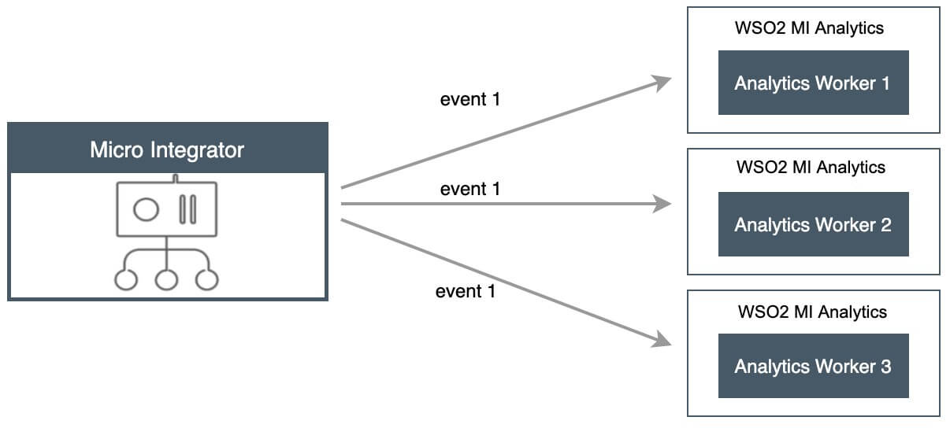](https://apim.docs.wso2.com/en/4.1.0/assets/img/integrate/mi-analytics/ob-all-events-to-all-servers.jpg)

The Analytics receiver URL should be configured with the following format in the Micro Integrator:

{**tcp**://Analytics-1>:<port>}, {**tcp**://Analytics-2>:<port>}, {**tcp**://<Analytics-3>:<port>}

Example configuration in the deployment.toml file of the Micro Integrator:

[monitoring]

ei_analytics.server_url = "{tcp://10.100.2.32:7611},{ tcp://10.100.2.33:7611}, {tcp://10.100.2.34:7611}"

ei_analytics.auth_server_url = "{tcp://10.100.2.32:7612},{ tcp://10.100.2.33:7612}, {tcp://10.100.2.34:7612}"

ei_analytics.username = "admin"

ei_analytics.password = "admin"

**Failover configuration**

When using the failover configuration in publishing events to Analytics, events are sent to multiple Analytics servers in a sequential order based on priority. You can specify multiple Analytics servers so that events can be sent to the next server in the specified sequence (in a situation where they were not successfully sent to the first server).

In the scenario depicted in the image below, - The events are first sent to Analytics-1. - If it is unavailable, then events are sent to Analytics-2. - If Analytics-2 is also unavailable, then the events are sent to Analytics-3.

[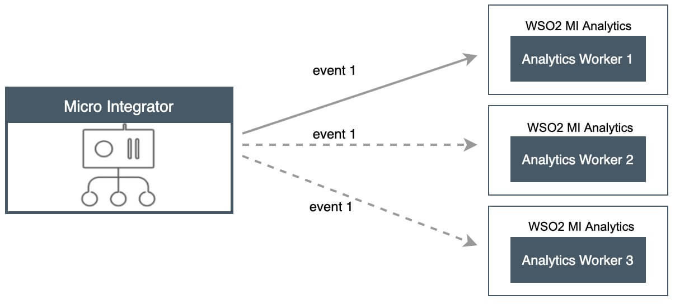](https://apim.docs.wso2.com/en/4.1.0/assets/img/integrate/mi-analytics/ob-fail-over.jpg)

The Analytics receiver URL should be configured with the following format in the Micro Integrator:

tcp://<**Analytics-1**>:<**port**>|tcp://<**Analytics-2**>:<**port**>|tcp://<**Analytics-3**>:<**port**>

[monitoring]

ei_analytics.server_url = "tcp://10.100.2.32:7611|tcp://10.100.2.33:7611|tcp://10.100.2.34:7611"

ei_analytics.auth_server_url = "tcp://10.100.2.32:7612|tcp://10.100.2.33:7612|tcp://10.100.2.34:7612"

ei_analytics.username = "admin"

ei_analytics.password = "admin"

Access the MI Analytics Portal

Let's use **MI Analytics** to view and monitor **statistics** and **message tracing**.

You can monitor the following statistics and more through the MI Analytics Portal:

* Request Count
* Overall TPS
* Overall Message Count
* Top Proxy Services by Request Count
* Top APIs by Request Count
* Top Endpoints by Request Count
* Top Inbound Endpoints by Request Count
* Top Sequences by Request Count

**Tip**

Monitoring the usage of the integration runtime using statistical information is very important for understanding the overall health of a system that runs in production. Statistical data helps to do proper capacity planning, to keep the runtimes in a healthy state, and for debugging and troubleshooting problems. When it comes to troubleshooting, the ability to trace messages that pass through the mediation flows of the Micro Integrator is very useful.

Before you begin

* Set up the [MI Analytics deployment](https://apim.docs.wso2.com/en/4.1.0/install-and-setup/setup/mi-setup/observability/setting-up-classic-observability-deployment).
* Note the following server directory in your deployment.

|  |  |
| --- | --- |
| <MI_ANALYTICS_HOME> | This is the root folder of your MI Analytics installation. |

Step 1 - Start the servers

Let's start the servers in the given order.

Step 1.1 - Start the Analytics Server

**Note**

Be sure to start the **Analytics** server before [starting the Micro Integrator](https://apim.docs.wso2.com/en/latest/mi-analytics/using-the-analytics-dashboard/#starting-the-micro-integrator).

1. Open a terminal and navigate to the <MI_ANALYTICS_HOME>/bin directory.
2. Start the Analytics server by executing the following command:

On MacOS/Linux/Centos

sh server.sh

On Windows

Step 1.2 - Start the Micro Integrator

Once you have [started the Analytics Server](https://apim.docs.wso2.com/en/latest/mi-analytics/using-the-analytics-dashboard/#starting-the-analytics-server), you can [start the Micro Integrator](https://apim.docs.wso2.com/en/4.1.0/install-and-setup/install/installing-the-product/installing-mi/).

Step 1.3 - Start the Analytics Portal

1. Open a terminal and navigate to the <MI_ANALYTICS_HOME>/bin directory.
2. Start the Analytics Portal's runtime by executing the following command:

On MacOS/Linux/Centos

sh portal.sh

On Windows

In a new browser window or tab, open the Analytics Portal using the following URL: https://localhost:9645/analytics-dashboard. Use admin for both the username and password.

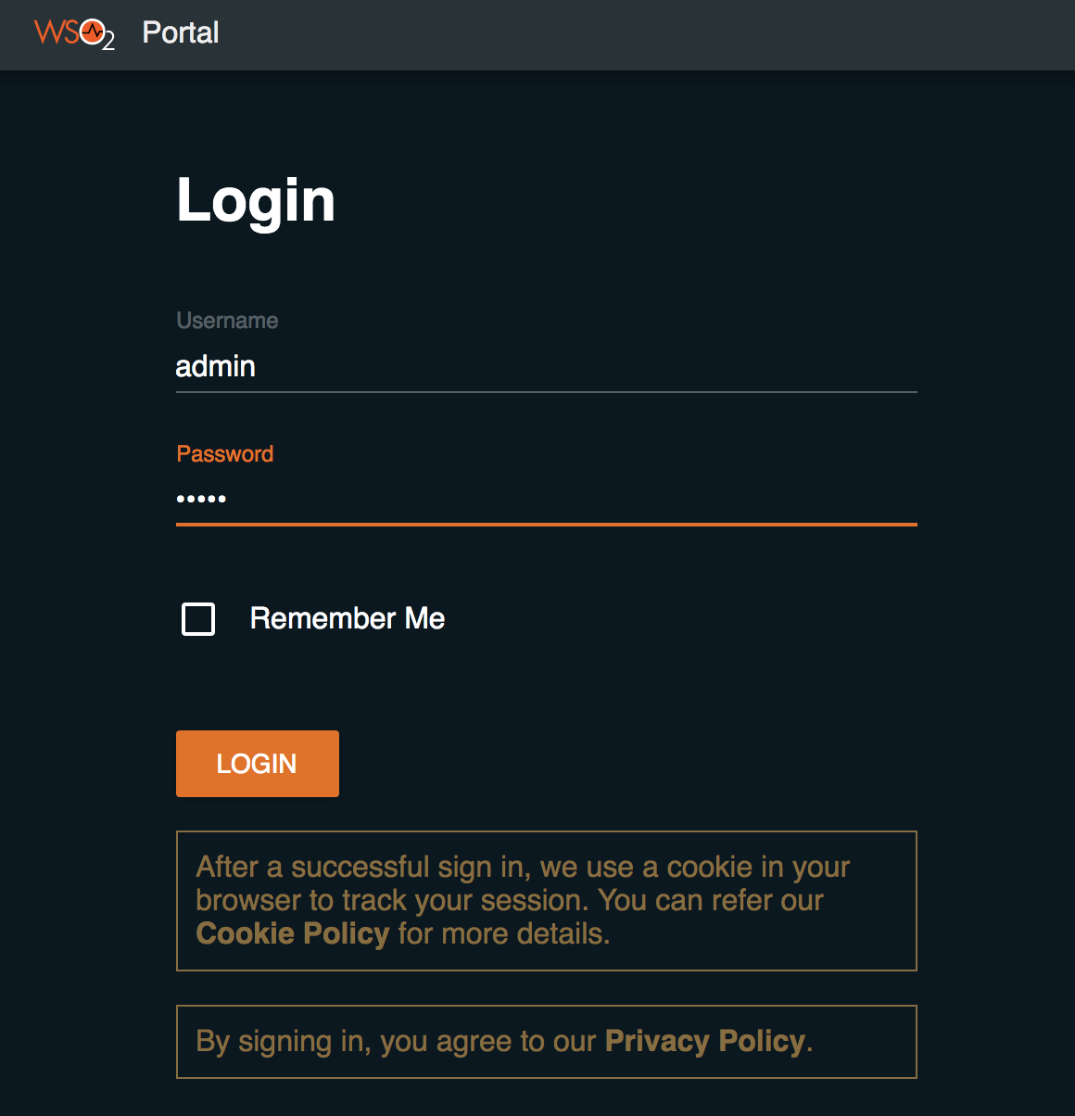

Step 2 - Publish statistics to the Portal

Let's **test this solution** by running the [service chaining](https://apim.docs.wso2.com/en/4.1.0/tutorials/integration-tutorials/exposing-several-services-as-a-single-service) tutorial. When the artifacts deployed in the Micro Integrator are invoked, the statistics will be available in the portal.

Follow the steps given below.

Step 1: Deploy integration artifacts

Step 2: Start the backend

Step 3: Sending messages

Step 3 - View the Analytics Portal

**Info**

* The Analytics Portal has been renamed to Micro Integrator Analytics as it contains MI related analytics.
* You need to get the [latest product updates](https://updates.docs.wso2.com/en/latest/updates/overview/) for your product to view these changes in the current version of WSO2 API-M. This change is available as a product update in Integrator Analytics 7.1.0 from June 18, 2021 onwards.

**Note**

You can deploy updates in a production environment only if you have a valid subscription with WSO2. Read more about [WSO2 Updates](https://wso2.com/updates).

Once you have signed in to the Analytics Portal server, click the **Micro Integrator Analytics** icon shown below to open the portal.

[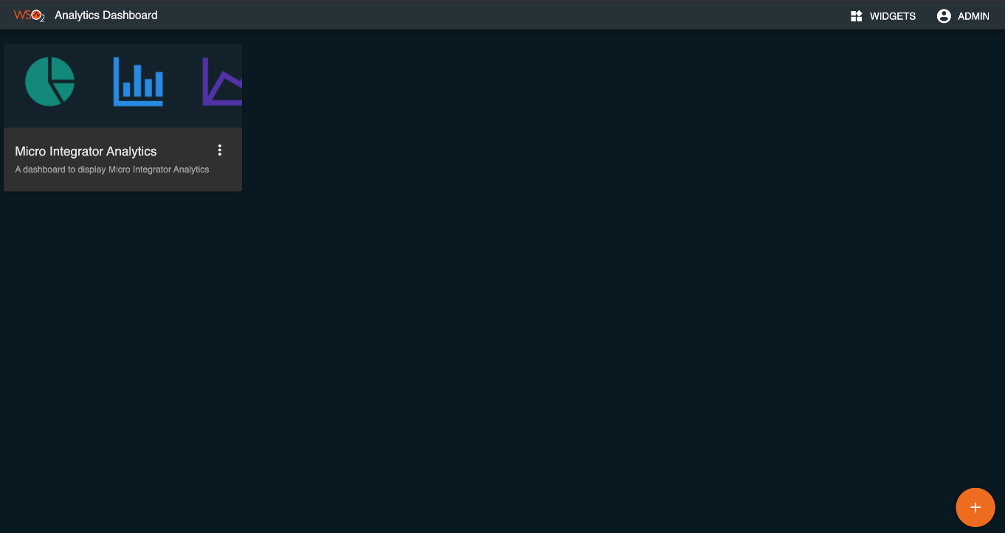](https://apim.docs.wso2.com/en/4.1.0/assets/img/integrate/mi-analytics/119132315/mi-dashboard.png)

Statistics overview

View the statistics overview for all the integration artifacts that have published statistics:

[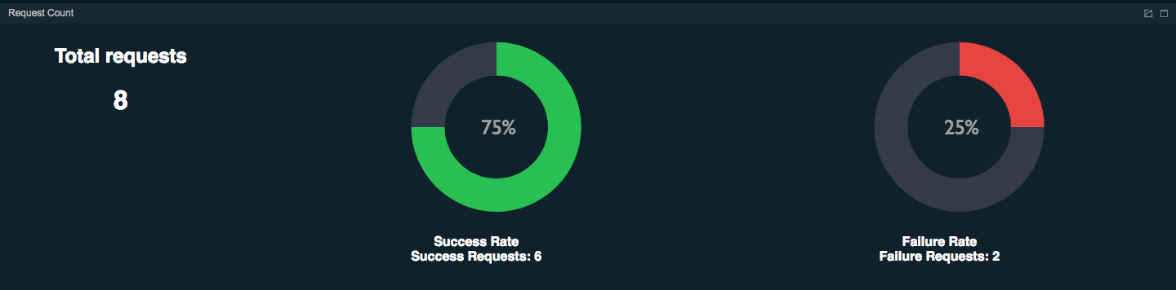](https://apim.docs.wso2.com/en/4.1.0/assets/img/integrate/mi-analytics/119132315/119132316.png)

Transactions per second

The number of transactions handled by the Micro Integrator per second is mapped on a graph as follows.

[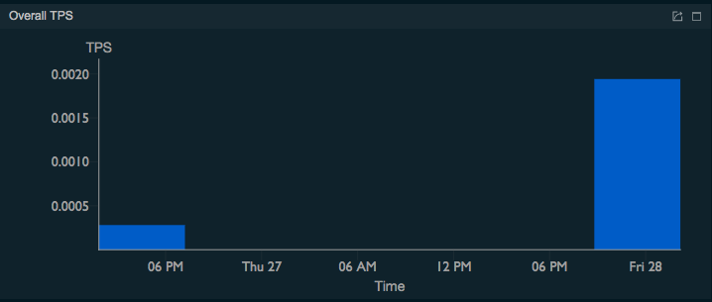](https://apim.docs.wso2.com/en/4.1.0/assets/img/integrate/mi-analytics/119132315/119132326.png)

Overall message count

The success rate and the failure rate of the messages received by the Micro Integrator during the last hour are mapped in a graph as follows.

[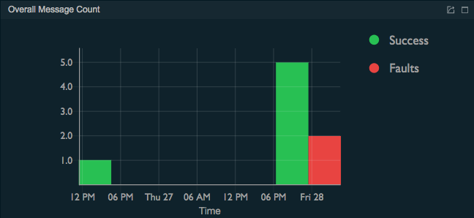](https://apim.docs.wso2.com/en/4.1.0/assets/img/integrate/mi-analytics/119132315/119132325.png)

Top APIs by request

The HealthcareAPI REST API is displayed under **TOP APIS BY REQUEST COUNT** as follows.

[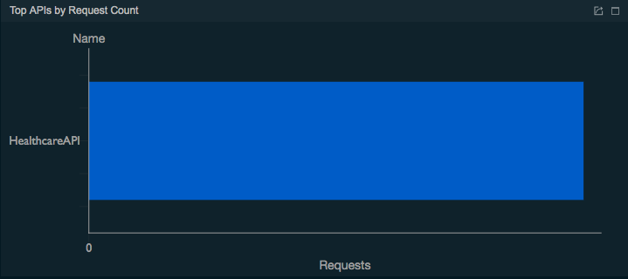](https://apim.docs.wso2.com/en/4.1.0/assets/img/integrate/mi-analytics/119132315/119132324.png)

Endpoints by request

The three endpoints used for the message mediation are displayed under **Top Endpoints by Request Count** as shown below.

[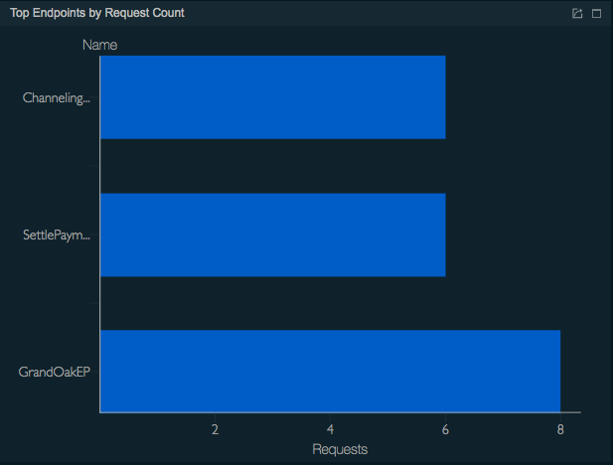](https://apim.docs.wso2.com/en/4.1.0/assets/img/integrate/mi-analytics/119132315/119132318.png)

Per API requests

In the Top APIS BY Request COUNT gadget, click HealthcareAPI to open the **OVERVIEW/API/HealthcareAPI** page. The following is displayed.

* The **API Request Count** gadget shows the total number of requests handled by the StockQuoteAPI REST API during the last hour:  
  [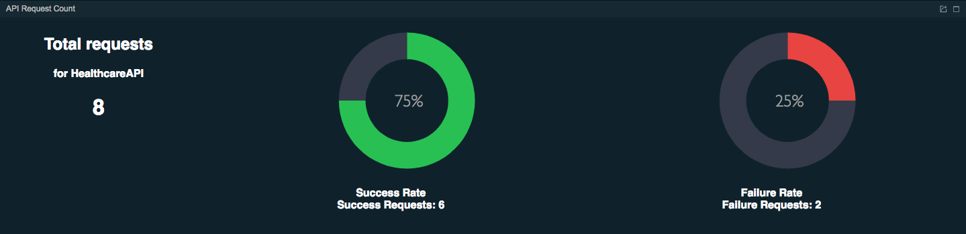](https://apim.docs.wso2.com/en/4.1.0/assets/img/integrate/mi-analytics/119132315/119132323.png)
* The **API** **Message Count** gadget maps the number of successful messages as well as failed messages at different times within the last hour in a graph as shown below.  
  [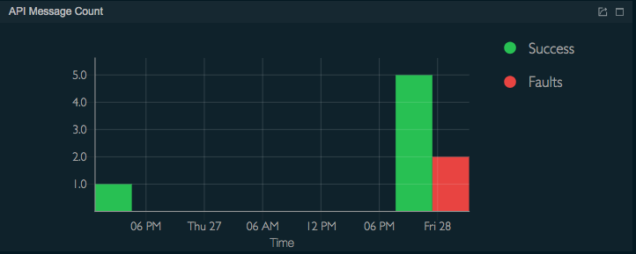](https://apim.docs.wso2.com/en/4.1.0/assets/img/integrate/mi-analytics/119132315/119132322.png)
* The **API** **Message Latency** gadget shows the speed with which the messages are processed by mapping the amount of time taken per message at different times within the last hour as shown below.  
  [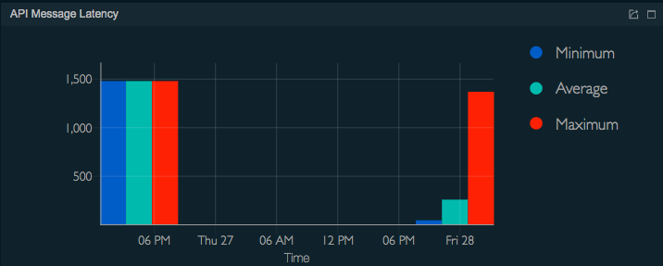](https://apim.docs.wso2.com/en/4.1.0/assets/img/integrate/mi-analytics/119132315/119132321.png)
* The **Messages** gadget lists all the the messages handled by the StockQuoteAPI REST API during the last hour with the following property details as follows.  
  [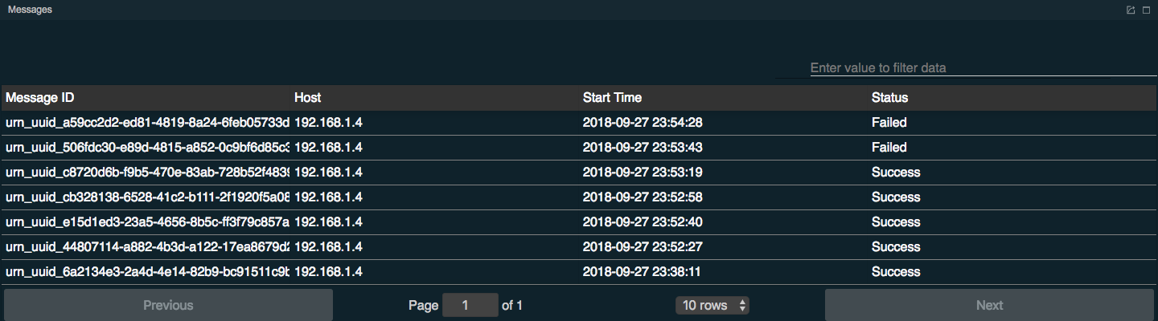](https://apim.docs.wso2.com/en/4.1.0/assets/img/integrate/mi-analytics/119132315/119132320.png)
* The **Message Flow** gadget illustrates the order in which the messages handled by the StockQuoteAPI REST API within the last hour passed through all the mediation sequences, mediators and endpoints that were included in the message flow as shown below.  
  [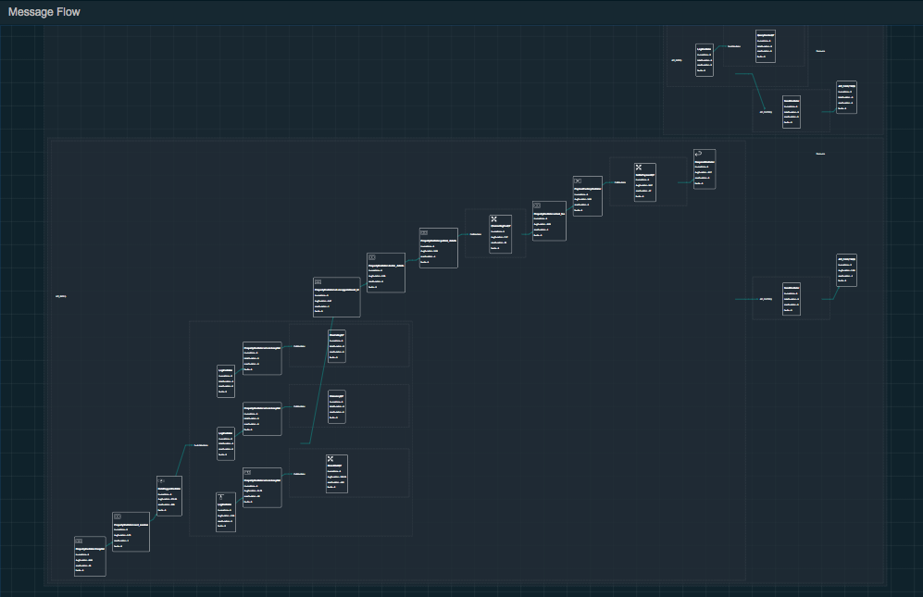](https://apim.docs.wso2.com/en/4.1.0/assets/img/integrate/mi-analytics/119132315/119132319.png)

Per endpoint requests

In the **Top Endpoints by Request Count** gadget, click one of the endpoints to view similar statistics per endpoint.

* ChannelingFeeEP
* SettlePaymentEP
* GrandOaksEP

You can also navigate to any of the artifacts by using the top-left menu as shown below. For example, to view the statistics of a specific endpoint, click **Endpoint** and search for the required endpoint.

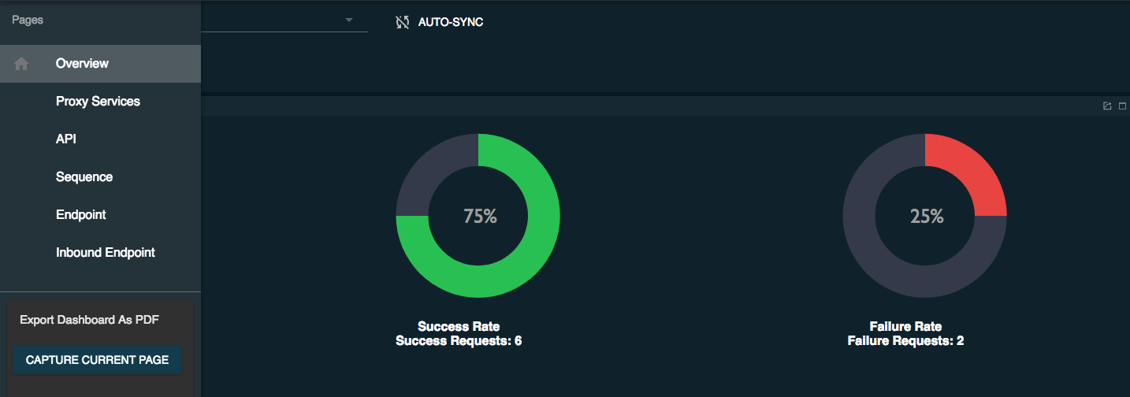

Message tracing

When you go to the [Analytics Portal](https://apim.docs.wso2.com/en/latest/mi-analytics/using-the-analytics-dashboard/#step-13-start-the-analytics-portal) the message details will be logged as follows:

